Add Service to Allowed List in SystmOne

In order to maintain record sharing you may need to add new Leeds Community Healthcare Trust organisations to your ‘Share in Rules’.

Organisation settings
- Select Setup Users & Policy Share In Rules…
- Select the Custom option
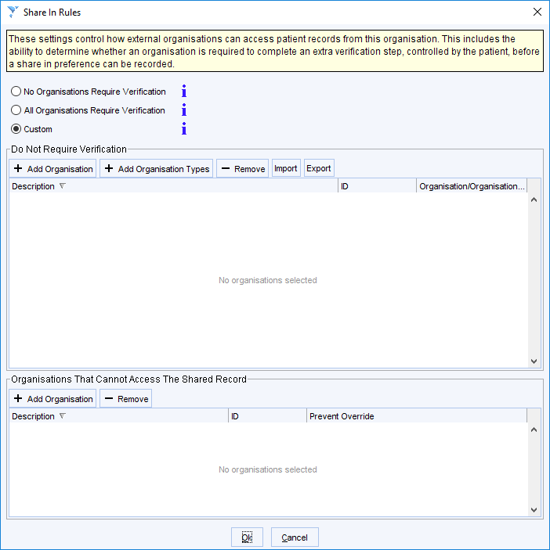

Creating an Allowed list
Organisations on the Allowed list are able to record the patients’ consent to share in without the need for an extra verification step
- To add an organisation type (e.g. all child health units):
  - click the + Add Organisation Type button in the Do Not Require Verification section
  - tick the organisation type(s) to include and click OK
- To add an organisation to the list manually:
  - Click the + Add Organisation button in the Do Not Require Verification section
  - Search for the required organisation– Leeds Community Integrated Wound Management,– ODS code H5X1S - and click OK

Removing an Organisation from the Allowed list
- To remove an organisation from the list:
  - Highlight the required organisation and click the – Remove button

