GP Connect in EMIS

You may already have configured EMIS to use GP Connect. If you haven’t or if you’re unsure follow the steps below.

GP Connect Configuration
1. Access Organisation Configuration.
- Click, point to Configuration, and then select Organisation Configuration. The Organisation Configuration screen is displayed.
- In the navigation pane, click Organisation.
- On the ribbon, click Edit. The Edit Organisation screen is displayed.
Click GP Connect Configuration in the left-hand pane. The GP Connect Configuration screen is displayed.

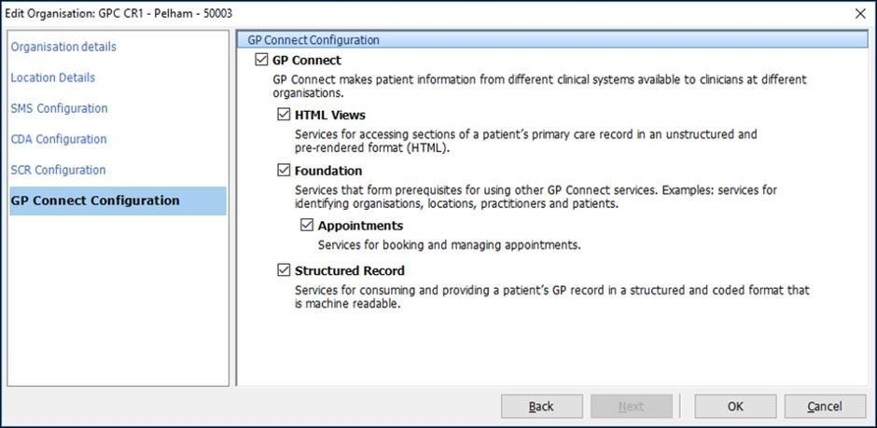
- Select the box beside GP Connect.
- Select the box beside the service(s) you want to enable.
- Click OK.
The service(s) are now enabled.

Add Organisation Group
- Access Organisation Configuration.
Click, point to Configuration, and then click Organisation Configuration.
Select Organisation Groups from the navigation pane. The Organisation Configuration screen is displayed.
- On the ribbon, click Add.
The Add Organisation Group screen is displayed.

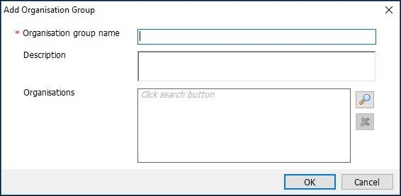
- On the Add Organisation Group screen, type the Organisation group name and Description in the appropriate fields.

NOTE: ensure you type your practice name as the system does not allow duplicate entries so if you name it something generic that has likely been used before it won’t work?
- Click beside the Organisations field to search for an Organisation. The Find Organisation screen is displayed.
- On the Find Organisations screen, type the practice Code, and then click. Double click to add to the group
- Click On the Find Organisations screen, type H5X1S this is Integrated Wound Management ODS code, and then double click to add to the group. Click ok to create the group .

Subscribe to the Organisation Group
- All users can view organisation groups created by other users if your practice is a part of the organisation group. Subscribing to an organisation group allows users to filter through organisation groups.
- You must already be a member of the group you want to subscribe to.
- Access Organisation Configuration.
Click, point to Configuration, and then click Organisation Configuration.
Select Organisation Groups from the navigation pane. The Organisation Configuration screen is displayed.
- Click Organisation Groups in the navigation pane.
- On the ribbon, click All Organisation Groups.
All organisations are displayed in the Organisation Groups pane.
- From the Organisation Groups pane, select the group you want to subscribe to.
- On the ribbon, click Subscribe Organisation Group.
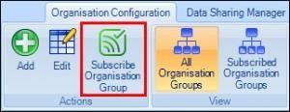
You are now subscribed to this organisation group.
Click Subscribed Organisation Groups to view groups you are subscribed to.
- Double-click the organisation.
The organisation is now listed in the Selected Items pane.
- Click OK.
The Add Organisation Group screen is displayed, with the selected organisations listed in the Organisations field.
- Click OK.
The organisations are listed in the Organisation Configuration screen.

