Replacement of Generic Wound Assessment to Wound / Lower Limb Assessment Template

Roles and Responsibilities / who needs to see this communication? (Target Audience)
This communication applies to all registered and non-registered clinical staff within primary care and all Leeds Community Healthcare Business Units who undertake wound assessments or wound care.
What is new? Why is there a change?
A new version of the Generic Wound Assessment template called Wound / Lower Limb Assessment Template has been developed and will be used across primary and community care in Leeds from 7th March 2022 to inform and continually improve quality and standards of wound care across Leeds.

The Wound / Lower Limb Assessment Template is available in ‘Templates’ on the relevant clinical tree for Emis and System One.

The template is a comprehensive wound assessment which aids clinical decision making in relation to the correct treatment and management of wounds. It combines the Generic Wound Assessment and the Lower Limb Assessment and includes:
- The new Clinical Care Frameworks
- A link to the Wound Formulary
- Prompts to refer to other services, e.g. referral forms for diabetic foot wounds
- Screening tools (e.g. Purpose T), to be used as clinically indicated
- Links to the Leeds Health Pathway.

If your practice uses Ardens templates or has created bespoke wound care templates we kindly ask that you adopt the Wound / Lower Limb Assessment Template as it incorporates:
- The Commissioning for Quality and Innovation (CQUIN) framework
- The National Wound Care Strategy
- National Minimum Data Set requirements
- Standardised read codes so we can analyse wound care outcomes across primary and community care to inform and continually improve quality and standards of wound care across Leeds.
Description of Change/Clinical Guidance
The new Wound / Lower Limb Assessment Template is a comprehensive assessment and review tool; it includes wound assessment and lower limb assessment. The template will:
- Aid clinicians in decision making in relation to the correct treatment and management of wounds
- Support standardisation of documentation
- Promote integrated ways of working as per the GP Confederation Integration Proposal (2021)

Key features include:
- The same template will be used across primary and community care for each encounter with the patient
- Up to ten wounds can be monitored and updated on the same template
- The assessment does not need to be completed/repeated by another clinician or service until the review date
- Template entries will be visible on SystmOne and Emis to all clinicians involved in patient care across primary and community care
- Non-registered colleagues will use the same template and complete appropriate sections for the care they deliver.
Date of implementation:
Roll out of the Wound / Lower Limb Assessment template will take place on Monday 7th March 2022 and will include primary care, neighbourhood teams and Leeds Hospices. Broader roll-out with other system partners is anticipated in due course.
Who to contact:
Emma Mallinson - Clinical Pathway Lead for Tissue Viability Service/Tissue Viability Nurse Specialist
Telephone: 0113 8433730/07946055093
Email: emma.mallinson@nhs.net
Screenshots
Emis: CHECK
SystmOne Live: CHECK

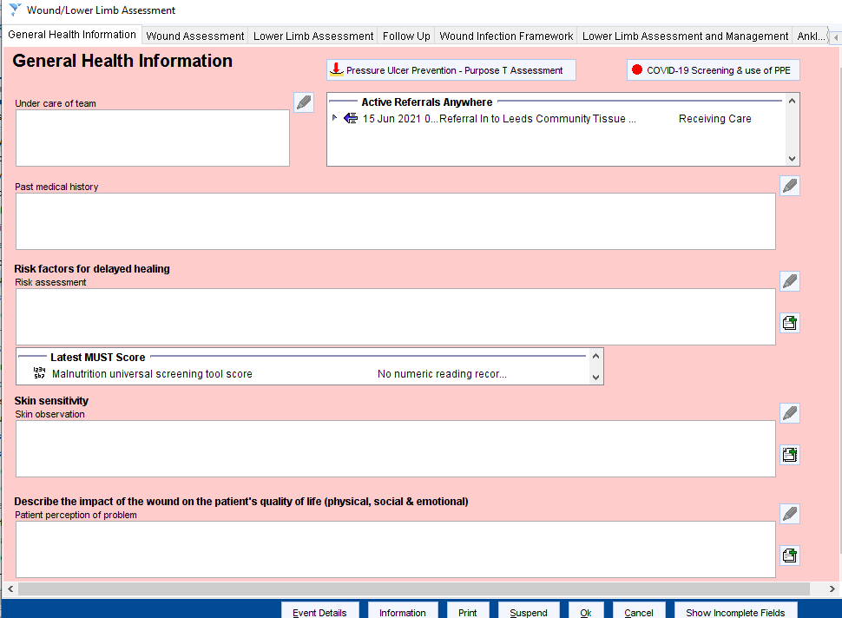

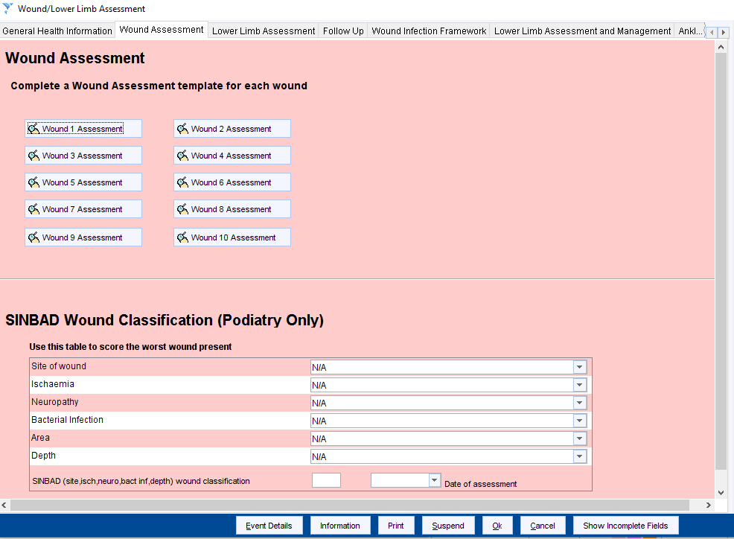

Within the ‘Plan of Care’ for each wound assessment within the template, there are boxes available to document the dressing type used and visit frequency as well as a link to the Wound Formulary. There are prompts around referring to other services as clinically indicated and links to the Leeds Health Pathway referral forms for Diabetic foot wounds (these links will only work in SystmOne Live and Emis (?)).
