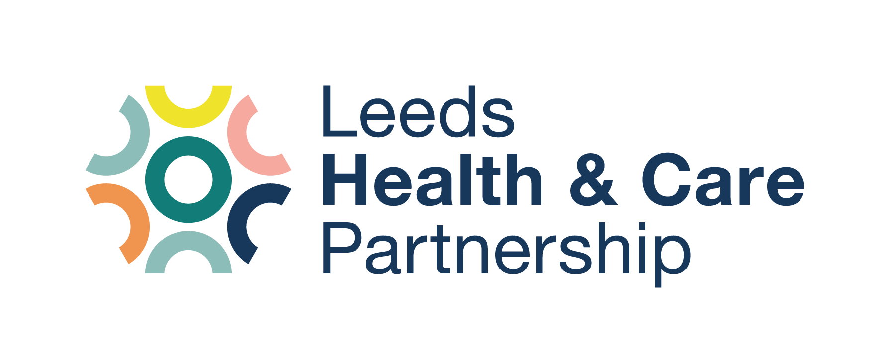

Leeds ICB Primary Care &
Medicines Optimisation Updates
SUBMISSION TEMPLATE

Submission Template Guidance
- Please use font Calibri, size 16 for the Heading and size 12 for text body.
- Please ensure that you include a Heading.
- Please note that information will not be edited and should be exact wording ready to copy and paste.
- Please ensure that any links contained in your information are included/attached and will be accessible to others.
- If a link is not available or accessible please attach a PDF/Word version with your submission template.
- Please use a maximum of 250 words if possible.

Heading | Leeds GP Confederation – March Newsletter
Text Body | Leeds GP Confederation’s March Newsletter is now live. This month focuses on Enhanced Access, Community Ambulatory Paediatric Service & Leeds Sexual Health services. Including:  - Patient feedback data  - Additional Services Offered Within Enhanced Access  - Stepping up to support system pressures  - Learning Disability Annual Health Checks  Please view the full newsletter on the Confed website here.
Please return the completed submission template to wyicb-leeds.pccomms@nhs.net
The Leeds ICB Primary Care & Medicines Optimisation update will be issued weekly on a Wednesday afternoon.
The deadline for completed submission templates will be Tuesday at 12noon.
Templates submitted after this will feature in the next update.

